**Effect of COVID-19 on Universities Enrollment**

**Issue:**

The education sector has been affected by the COVID-19 pandemic. This affected the enrollment of students in universities. Low enrollment can cause reduced revenues and reputation to the university. We want to study the available data to see if the pandemic has changed the attraction of students to some colleges and programs.

**Solution:**

Given the available data, we will provide an analysis of the data related to some universities in UAE. The analysis has been conducted using Python Jupyter notebook and Power BI report. The created visualizations will reveal hidden insights and help in understanding the impact of the pandemic. This will allow the universities to shape their policies and requirements to attract more students.

**Data Description:**

* **UAUE Stats 2017-2020**

The available data describe the number of students enrolled in different colleges in UAEU. They include different aspects of the students (gender, nationality, and study level). The data are split across three different files to represent three years (from 2017 to 2020). The total number of enrollments is 43642.

**Data Attributes:**

* **UAUE Stats 2017-2020**

|  |  |  |  |
| --- | --- | --- | --- |
| **Attribute** | **Type** | **Number of values** | **Description** |
| **Year** | ordinal | 3 | represents the year of enrollment |
| **College_Desc** | categorical | 10 | the college in which the student enrolled |
| **Gender_Desc** | Binary | 2 | whether the student is male of female |
| **Nationality** | Binary | 2 | to indicate if the student is local or non-local (foreigner) |
| **Student_Level** | categorical | 4 | if the student is undergraduate, master, or doctorate |
| **Total** | Numerical | Continuous range | number of students enrolled |

**Basic Analysis:**

* **Enrollment by year:**

From the pie chart, there is no significant change in the percentage of enrollment during the past three years.

* **Distribution of nationality:**

Clearly, UAUE attracts more locals (Emiratis) than non-locals in all the three years with over 75% of overall enrollment. This could be due to the tuition fees of the university. All in all, the ratio between both nationalities is almost the same in all years.

* **Distribution of the student level:**

About 92% of the students applied for undergraduate level during the past three years and no one applied for professional certificate in 2020. We can see all levels have maintained the same percentage in all years.

* **Distribution of gender:**

We can see that females are dominant as compared to males in the three years. There is no significant change in males’ enrollment across the three years. There is a change of about 11.6% in female’s enrollment in the last two years. There is almost a fixed ratio between both genders across all years.

* **Distribution of university colleges:**

The top three colleges are humanities and social sciences, engineering, business and economics. They contribute to 26.4%, 20.4%, and 13.7% respectively of the overall enrollment across the three years. There was no enrollment in the academic affairs college in the 2018 and 2019. We thought that majority of the students will start enrolling in medicine college during this pandemic, but this wasn’t the case.

**Advanced Analysis:**

* **Distribution of nationalities in different student levels:**

Most of the undergraduate and master students are locals, while most of the doctorate students are non-locals. Regarding the professional certificate, only 8 applied and one of them is local.

* **Distribution of nationalities across university’s colleges:**

In all colleges, most of the students are locals, except for the academic affairs which suffers from low enrollment. Also, there are no significant changes across colleges, except for the science college where the enrollment of the non-locals has increased significantly in all three years. Even in colleges with low enrollment, most of the students applied are locals.

* **Distribution of gender across university’s colleges:**

In the top three colleges, females are dominant. Even in the low enrollment colleges, at least 76% of the students are females.

* **Distribution of gender over student level:**

In all three years, most of the undergraduate are females. Overall, males and females maintain almost the same distribution.

**Data Description:**

* HCT Enrollment by Campus

This dataset contains enrollment information on each campus for HCT from the 2015-16 - 2019-20 academic years. Each campus has a column for enrollment year, and the number of students enrolled for that period.

**Data Attributes:**

|  |  |  |  |
| --- | --- | --- | --- |
| **Attribute** | **Type** | **Number of values** | **Description** |
| **Year** | Ordinal | 5 | represents the year of enrollment |
| **Campus** | categorical | 15 | contains which campus the count is for |
| **Count** | Numerical | Continuous Range | number of students enrolled |

**Basic Analysis:**

* **AAM Campus:**

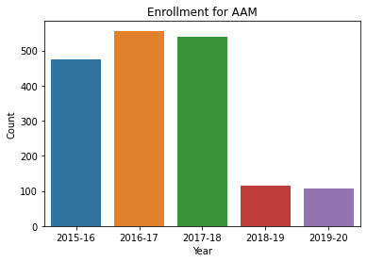

AAM had a very sharp decline in enrollment during Covid with a 79% decrease starting in the 2018-2019 academic year.

* **AAW Campus:**

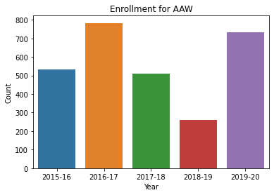

AAW had a 49% decrease in the 2018-19 year, but then more than doubled enrollment during 2019-2020.

* **ADM Campus:**

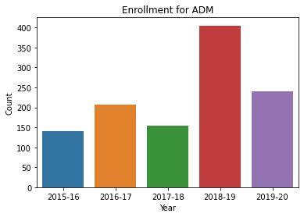

ADM had a 161% Increase during the 2018-19 year. Numbers went down the following year, but still higher than pre-pandemic numbers.

* **ADW Campus:**

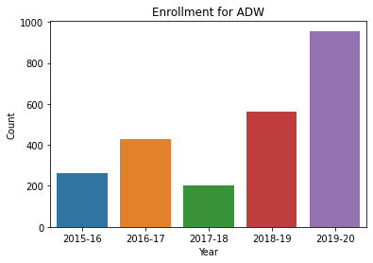

ADW saw a 177% increase during the 2018-19 year. Numbers nearly doubled again the following year.

* **DBM Campus:**

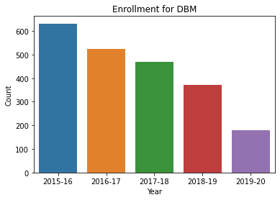

DBM saw a 21% decrease during the 2018-19 year. Numbers had been falling before the pandemic and then continued to fall afterwards with about half as many enrollments the following year.

* **DBW Campus:**

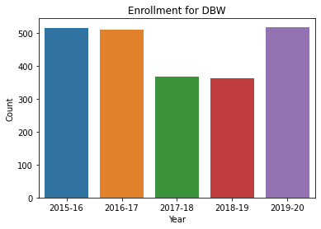

DBW has steady enrollment throughout the period of the database. There is only a 1.4% decrease from 2018-19 following another down year the year prior, and enrollment went back to normal levels the following year.

* **FJM Campus:**

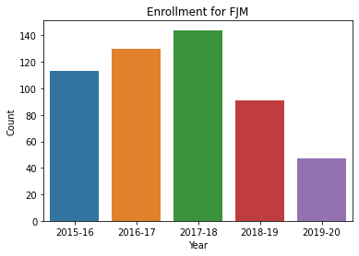

FJM say a 37% decrease in during the 2018-19 year. Numbers fell to around half the following year.

* **FJW Campus:**

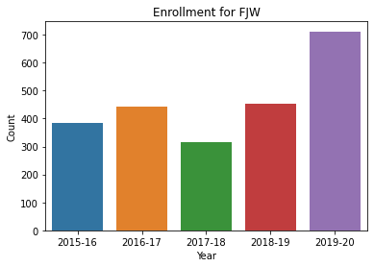

FJW saw a 44% increase during the 2018-19 year. Numbers increased by a similar margin the following year.

* **MZW Campus:**

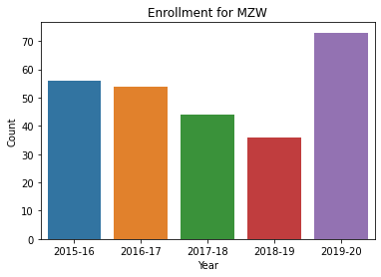

MZW saw a 18% decrease during the 2018-19 year. The following year had enrollment numbers higher than pre-pandemic numbers.

* **RKM Campus:**

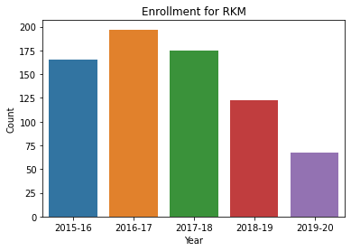

RKM saw a 30% decrease during the 2018-19 year. The following year had a similar decrease in enrollment.

* **RKW Campus:**

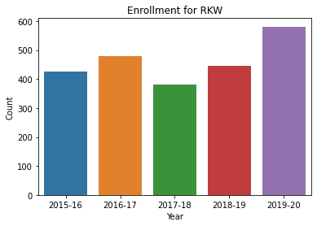

RKW saw a 17% increase in the 2018-19 year. The following year enrollment increased to the highest in the range of years.

* **RUM Campus:**

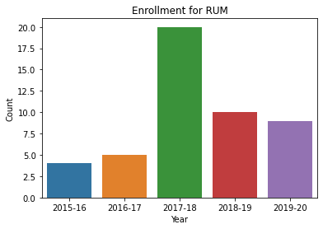

RUM is a small campus that saw a 50% decrease in the 2018-19 year which equates to 10 students. While this is a large percentage, it is still double the enrollment 2 years prior in 2016-17.

* **RUW Campus:**

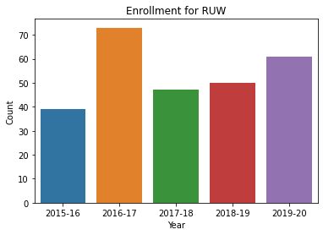

RUW saw a 6% increase in the 2018-19 year and an even larger increase the following year.

* **SJM Campus:**

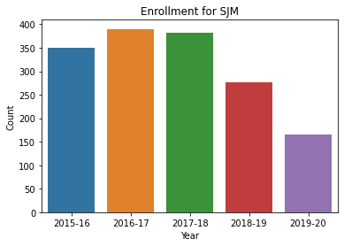

SJM saw a 27% decrease in the 2018-19 year. This decrease was even larger the following year.

* **SJW Campus:**

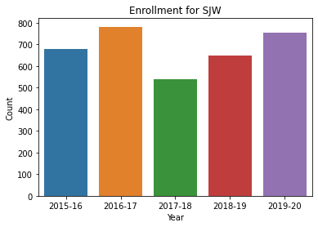

SJW had a down year prior to the 2018-19 year. Their numbers increased 20% in the 2018-19 year and another increase the following year.

* **All Campuses:**

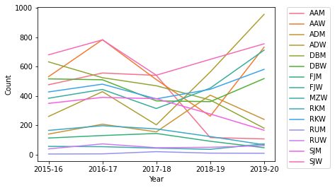

This graph of all the campuses show that there they all had different responses to the Covid outbreak and there was no uniform trend.

**Advanced Analysis:**

* **UAEU Enrollment Comparison:**

**2018-19:**

There was not a large change in enrollment overall for either HCT or UAEU.

* Enrollment for HCT *decreased* by 1.8%
* UAEU *increased* by only 0.7%

**2019-20:**

There a large difference between the enrollment change for HCT and UAEU in the 2019-20 year.

* Enrollment for HCT *increased*by 24%
* Enrollment for UAEU *decreased* by 9%